Section 1: Git dataflow: 2

Section 2 : Git Installation and configuration 2

Section 3: GIT-HUB: This section will create github 13

# Section 1: Git dataflow:

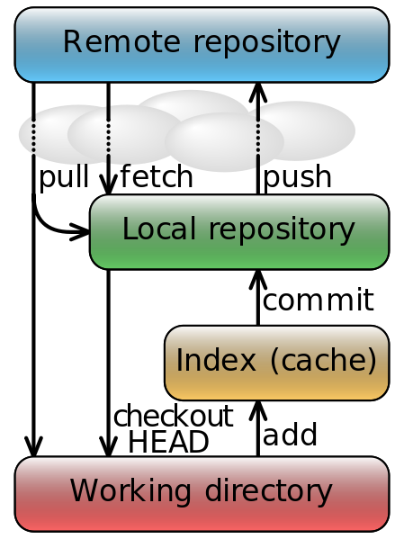

# Section 2 : Git Installation and configuration

1. Download git : <http://git-scm.com/>
2. Github (https://github.com/) and git-scm are two different thing:
   1. Git is a revision control system, a tool to manage your source code history. GitHub is a hosting service for Git repositories. So they are not the same thing: Git the tool, GitHub the service for projects that uses Git.
3. Once downloaded git-scm, install it usual ways. For mac there may be issue with registered developer. Use control button and click and it will allow installing git.
4. Configuration Settings:
   1. git config --global user.name “B Borah”
   2. git config –global user.email “[bootstrap@quest.careers](mailto:bootstrap@quest.careers)”

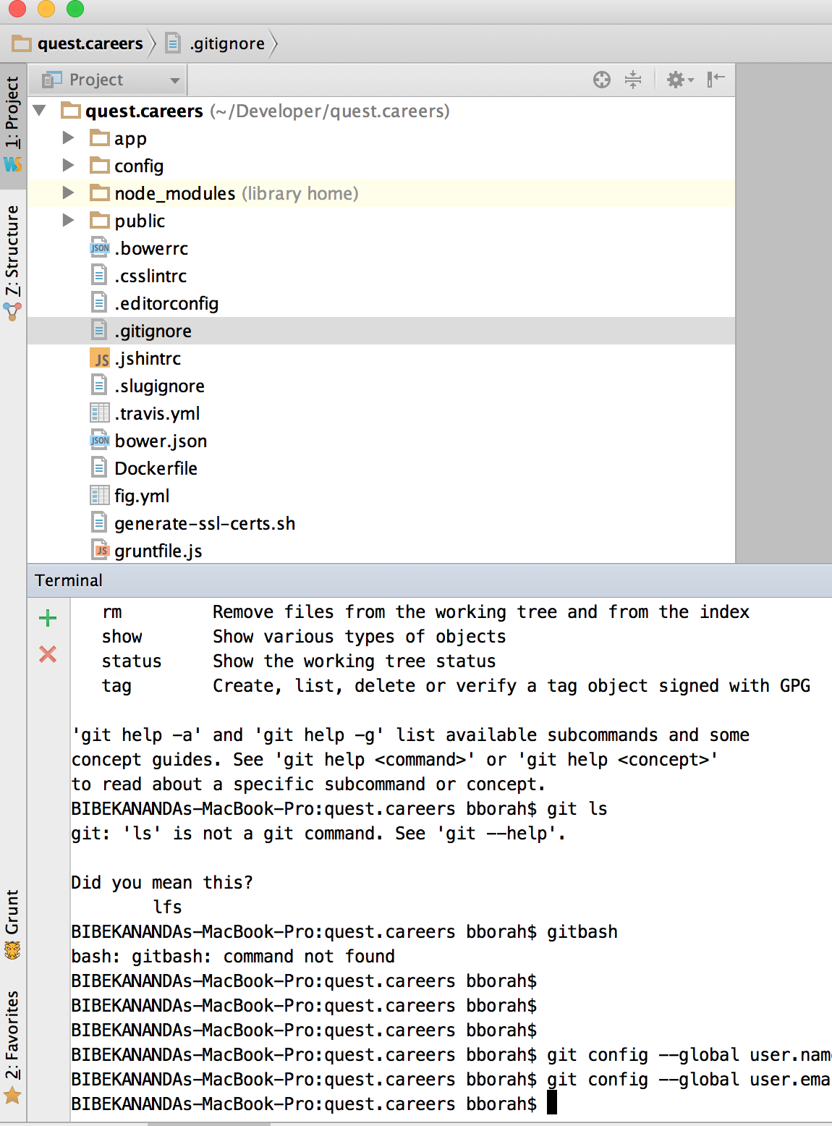

* 1. Enable version control in WebStrom

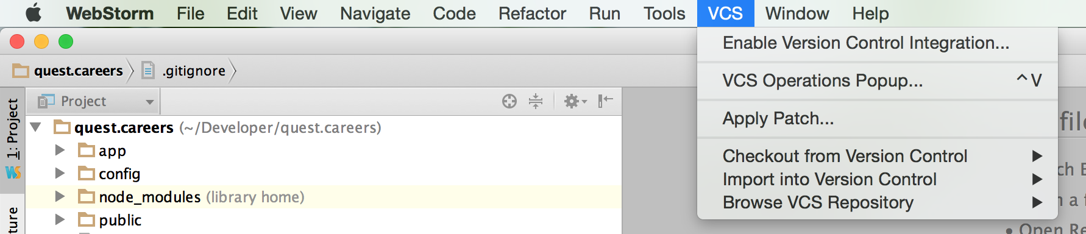

* 1. Select git and VCS

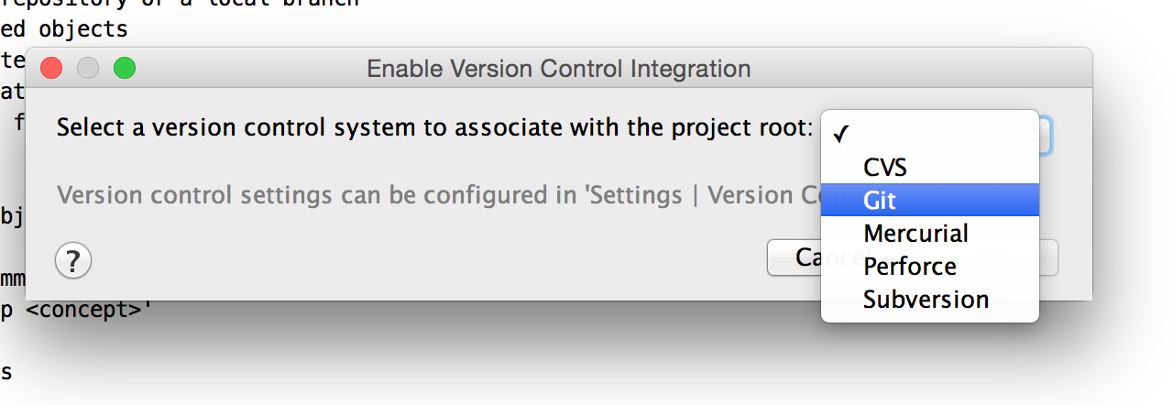

* 1. Version control icon will appear in webStrom:

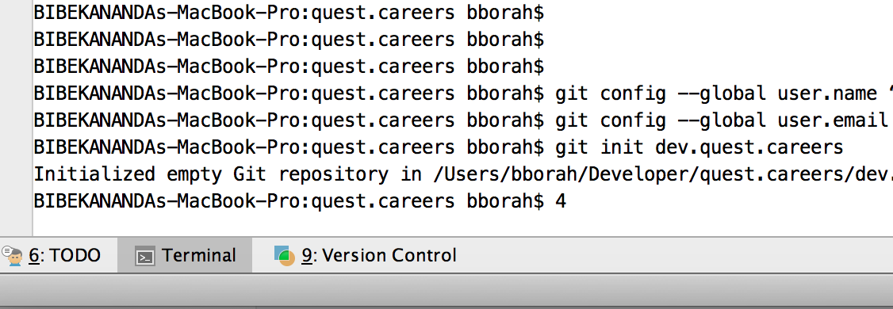

* 1. WebStrom provides full list of icons to version control, however initially we will use the commands:

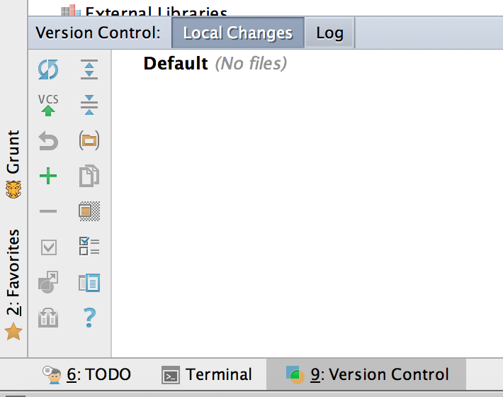

Using Git from command line:

* 1. Initialize a got project (git init “project name”): from the folder above the MEAJJS project folder:

$ git **init quest.careers**

Initialized empty Git repository in /Users/bborah/Developer/quest.careers/.git/

* 1. Once the empty project initiated (.git folder)

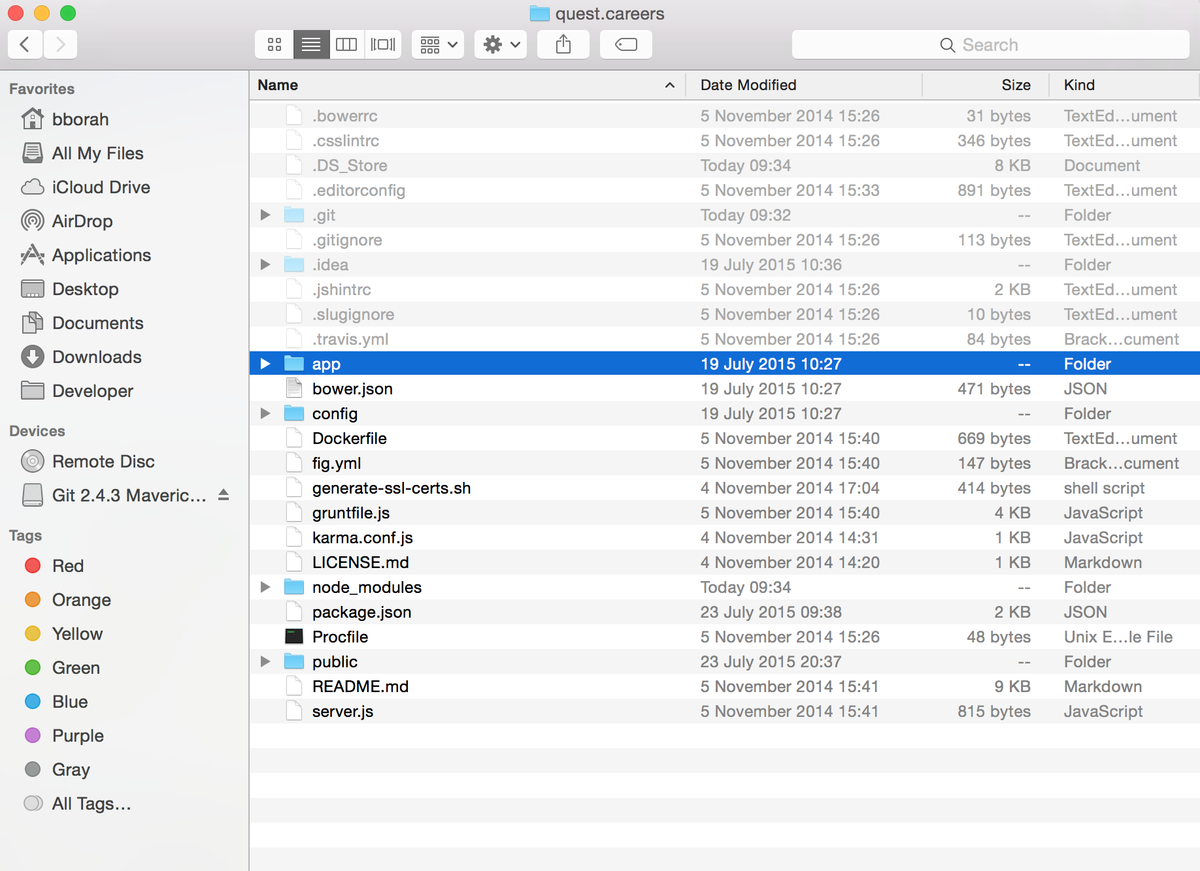

* 1. Folder inside git:

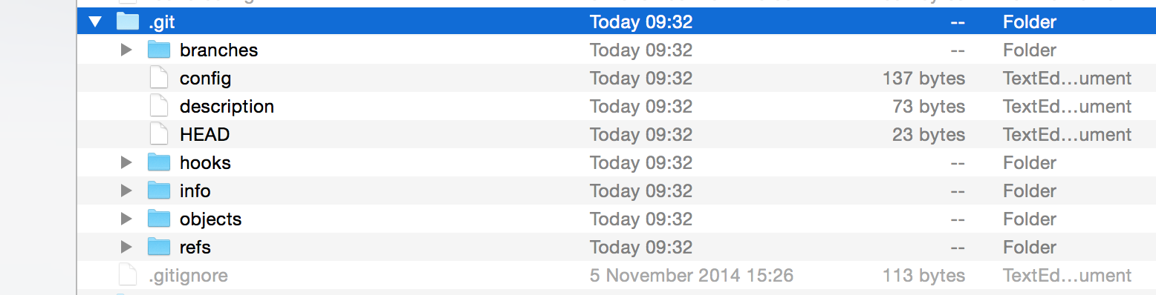

* 1. Check the status of git track on your project:

$ git status

**On branch master**

Initial commit

Untracked files:

(use "git add <file>..." to include in what will be committed)

.bowerrc

.csslintrc

.editorconfig

.gitignore

.jshintrc

.slugignore

.travis.yml

Dockerfile

LICENSE.md

Procfile

README.md

app/

bower.json

config/

fig.yml

generate-ssl-certs.sh

gruntfile.js

karma.conf.js

package.json

public/

server.js

nothing added to commit but untracked files present (use "git add" to track)

* 1. All our files are not yet track
  2. To add all the files you can use $git add . (the “.” Will add all the files)
  3. To add individually you need to use the file names $ git add <<file names>>
  4. Add all the MEANJS project files added to VCS by using “git add . “
  5. Check the status again:

$ git status

On branch master

Initial commit

Changes to be committed:

(use "git rm --cached <file>..." to unstage)

new file: .bowerrc

new file: .csslintrc

new file: .editorconfig

new file: .gitignore

new file: .jshintrc

new file: .slugignore

new file: .travis.yml

new file: Dockerfile

new file: LICENSE.md

new file: Procfile

new file: README.md

new file: app/controllers/core.server.controller.js

new file: app/controllers/errors.server.controller.js

new file: app/controllers/users.server.controller.js

new file: app/controllers/users/users.authentication.server.controller.js

new file: app/controllers/users/users.authorization.server.controller.js

new file: app/controllers/users/users.password.server.controller.js

new file: app/controllers/users/users.profile.server.controller.js

new file: app/models/user.server.model.js

new file: app/routes/core.server.routes.js

new file: app/routes/users.server.routes.js

new file: app/tests/article.server.routes.test.js

new file: app/tests/user.server.model.test.js

new file: app/views/404.server.view.html

new file: app/views/500.server.view.html

new file: app/views/index.server.view.html

new file: app/views/layout.server.view.html

new file: app/views/templates/reset-password-confirm-email.server.view.html

new file: app/views/templates/reset-password-email.server.view.html

new file: bower.json

new file: config/config.js

new file: config/env/all.js

new file: config/env/development.js

new file: config/env/production.js

new file: config/env/secure.js

new file: config/env/test.js

new file: config/express.js

new file: config/init.js

new file: config/passport.js

new file: config/strategies/facebook.js

new file: config/strategies/github.js

new file: config/strategies/google.js

new file: config/strategies/linkedin.js

new file: config/strategies/local.js

new file: config/strategies/twitter.js

new file: fig.yml

new file: generate-ssl-certs.sh

new file: gruntfile.js

new file: karma.conf.js

new file: package.json

new file: public/application.js

new file: public/config.js

new file: public/humans.txt

new file: public/modules/core/config/core.client.routes.js

new file: public/modules/core/controllers/header.client.controller.js

new file: public/modules/core/controllers/home.client.controller.js

new file: public/modules/core/core.client.module.js

new file: public/modules/core/css/core.css

new file: public/modules/core/img/brand/favicon.ico

new file: public/modules/core/img/brand/logo.png

new file: public/modules/core/img/footstep.png

new file: public/modules/core/img/glint.jpeg

new file: public/modules/core/img/loaders/loader.gif

new file: public/modules/core/services/menus.client.service.js

new file: public/modules/core/tests/header.client.controller.test.js

new file: public/modules/core/tests/home.client.controller.test.js

new file: public/modules/core/views/aboutus.client.view.html

new file: public/modules/core/views/contactus.client.view.html

new file: public/modules/core/views/footer.client.view.html

new file: public/modules/core/views/header.client.view.html

new file: public/modules/core/views/home.client.view.html

new file: public/modules/users/config/users.client.config.js

new file: public/modules/users/config/users.client.routes.js

new file: public/modules/users/controllers/authentication.client.controller.js

new file: public/modules/users/controllers/password.client.controller.js

new file: public/modules/users/controllers/settings.client.controller.js

new file: public/modules/users/css/users.css

new file: public/modules/users/img/buttons/facebook.png

new file: public/modules/users/img/buttons/github.png

new file: public/modules/users/img/buttons/google.png

new file: public/modules/users/img/buttons/linkedin.png

new file: public/modules/users/img/buttons/twitter.png

new file: public/modules/users/services/authentication.client.service.js

new file: public/modules/users/services/users.client.service.js

new file: public/modules/users/tests/authentication.client.controller.test.js

new file: public/modules/users/users.client.module.js

new file: public/modules/users/views/authentication/signin.client.view.html

new file: public/modules/users/views/authentication/signup.client.view.html

new file: public/modules/users/views/password/forgot-password.client.view.html

new file: public/modules/users/views/password/reset-password-invalid.client.view.html

new file: public/modules/users/views/password/reset-password-success.client.view.html

new file: public/modules/users/views/password/reset-password.client.view.html

new file: public/modules/users/views/settings/change-password.client.view.html

new file: public/modules/users/views/settings/edit-profile.client.view.html

new file: public/modules/users/views/settings/social-accounts.client.view.html

new file: public/robots.txt

new file: server.js

* 1. It will display green for added files
  2. To remove files from the cache ( init and add juts put the files in cache. Only commit will move it to the next stage)
     1. You can remove: git rm –cached . –r (note r for recursive)
  3. It will go back to init stage
  4. Now commit the changes: git commit –m <<MESSAGE>>

$ git commit -m "inital commit to the quest.careers"

[master (root-commit) 50ae8e5] inital commit to the quest.careers

97 files changed, 4137 insertions(+)

create mode 100644 .bowerrc

create mode 100644 .csslintrc

create mode 100644 .editorconfig

create mode 100644 .gitignore

create mode 100644 .jshintrc

create mode 100644 .slugignore

create mode 100644 .travis.yml

create mode 100644 Dockerfile

create mode 100644 LICENSE.md

create mode 100755 Procfile

create mode 100644 README.md

create mode 100644 app/controllers/core.server.controller.js

create mode 100644 app/controllers/errors.server.controller.js

create mode 100755 app/controllers/users.server.controller.js

create mode 100644 app/controllers/users/users.authentication.server.controller.js

create mode 100644 app/controllers/users/users.authorization.server.controller.js

create mode 100644 app/controllers/users/users.password.server.controller.js

create mode 100644 app/controllers/users/users.profile.server.controller.js

create mode 100755 app/models/user.server.model.js

create mode 100644 app/routes/core.server.routes.js

create mode 100644 app/routes/users.server.routes.js

create mode 100644 app/tests/article.server.routes.test.js

create mode 100644 app/tests/user.server.model.test.js

create mode 100644 app/views/404.server.view.html

create mode 100644 app/views/500.server.view.html

create mode 100644 app/views/index.server.view.html

create mode 100644 app/views/layout.server.view.html

create mode 100644 app/views/templates/reset-password-confirm-email.server.view.html

create mode 100644 app/views/templates/reset-password-email.server.view.html

create mode 100644 bower.json

create mode 100644 config/config.js

create mode 100644 config/env/all.js

create mode 100644 config/env/development.js

create mode 100644 config/env/production.js

create mode 100644 config/env/secure.js

create mode 100644 config/env/test.js

create mode 100755 config/express.js

create mode 100644 config/init.js

create mode 100755 config/passport.js

create mode 100644 config/strategies/facebook.js

create mode 100644 config/strategies/github.js

create mode 100644 config/strategies/google.js

create mode 100644 config/strategies/linkedin.js

create mode 100644 config/strategies/local.js

create mode 100644 config/strategies/twitter.js

create mode 100644 fig.yml

create mode 100644 generate-ssl-certs.sh

create mode 100644 gruntfile.js

create mode 100644 karma.conf.js

create mode 100755 package.json

create mode 100644 public/application.js

create mode 100644 public/config.js

create mode 100755 public/humans.txt

create mode 100755 public/modules/core/config/core.client.routes.js

create mode 100644 public/modules/core/controllers/header.client.controller.js

create mode 100644 public/modules/core/controllers/home.client.controller.js

create mode 100755 public/modules/core/core.client.module.js

create mode 100644 public/modules/core/css/core.css

create mode 100644 public/modules/core/img/brand/favicon.ico

create mode 100644 public/modules/core/img/brand/logo.png

create mode 100644 public/modules/core/img/footstep.png

create mode 100644 public/modules/core/img/glint.jpeg

create mode 100644 public/modules/core/img/loaders/loader.gif

create mode 100644 public/modules/core/services/menus.client.service.js

create mode 100644 public/modules/core/tests/header.client.controller.test.js

create mode 100644 public/modules/core/tests/home.client.controller.test.js

create mode 100644 public/modules/core/views/aboutus.client.view.html

create mode 100644 public/modules/core/views/contactus.client.view.html

create mode 100644 public/modules/core/views/footer.client.view.html

create mode 100644 public/modules/core/views/header.client.view.html

create mode 100644 public/modules/core/views/home.client.view.html

create mode 100644 public/modules/users/config/users.client.config.js

create mode 100755 public/modules/users/config/users.client.routes.js

create mode 100644 public/modules/users/controllers/authentication.client.controller.js

create mode 100644 public/modules/users/controllers/password.client.controller.js

create mode 100644 public/modules/users/controllers/settings.client.controller.js

create mode 100644 public/modules/users/css/users.css

create mode 100644 public/modules/users/img/buttons/facebook.png

create mode 100644 public/modules/users/img/buttons/github.png

create mode 100644 public/modules/users/img/buttons/google.png

create mode 100644 public/modules/users/img/buttons/linkedin.png

create mode 100644 public/modules/users/img/buttons/twitter.png

create mode 100644 public/modules/users/services/authentication.client.service.js

create mode 100644 public/modules/users/services/users.client.service.js

create mode 100644 public/modules/users/tests/authentication.client.controller.test.js

create mode 100755 public/modules/users/users.client.module.js

create mode 100644 public/modules/users/views/authentication/signin.client.view.html

create mode 100644 public/modules/users/views/authentication/signup.client.view.html

create mode 100644 public/modules/users/views/password/forgot-password.client.view.html

create mode 100644 public/modules/users/views/password/reset-password-invalid.client.view.html

create mode 100644 public/modules/users/views/password/reset-password-success.client.view.html

create mode 100644 public/modules/users/views/password/reset-password.client.view.html

create mode 100644 public/modules/users/views/settings/change-password.client.view.html

create mode 100644 public/modules/users/views/settings/edit-profile.client.view.html

create mode 100644 public/modules/users/views/settings/social-accounts.client.view.html

create mode 100755 public/robots.txt

create mode 100755 server.js

* 1. You can now see the status

$ git log

commit 50ae8e5cef3a740c4b9cc83baf20d568955a382f

Author: “B <“bootstrap@quest.careers”>

Date: Sun Jul 26 09:50:27 2015 +0100

inital commit to the quest.careers

* 1. Now modify a file – e.g. modified the file : /public/modules/users/views/authentication/signin.client.view.html
  2. The status command will show:

$ git status

On branch master

Changes not staged for commit:

(use "git add <file>..." to update what will be committed)

(use "git checkout -- <file>..." to discard changes in working directory)

modified: public/modules/users/views/authentication/signin.client.view.html

no changes added to commit (use "git add" and/or "git commit -a")

* 1. If you commit now the command will fail as the staging area is now cleaned up after the commit. So you need to add then commit.
  2. Add the file and commit changes:

$ git add public/modules/users/views/authentication/signin.client.view.html

$ git commit -m "inital commit to the quest.careers after removing the github login"

[master 905715d] inital commit to the quest.careers after removing the github login

1 file changed, 4 insertions(+), 4 deletions(-)

* 1. Check status:

$ git status

On branch master

nothing to commit, working directory clean

* 1. Other way to do it is to use the “git commit –a “

$ git commit -a

[master dcc0519] This is after changed of the signin file

1 file changed, 1 insertion(+), 1 deletion(-)

* 1. Note that this will require to enter the comments in a VI editor
  2. If you want to see changes made use “git diff”

$ git diff

diff --git a/public/modules/users/views/authentication/signin.client.view.html b/public/modules/users/views/authentication/signin.client.view.html

index aad3ed1..37ce8ea 100644

--- a/public/modules/users/views/authentication/signin.client.view.html

+++ b/public/modules/users/views/authentication/signin.client.view.html

@@ -1,5 +1,5 @@

<section class="row" data-ng-controller="AuthenticationController">

- <h3 class="col-md-12 text-center">Sign in using your existing accounts .. </h3>

+ <h2 class="col-md-12 text-center">Sign in using your existing accounts</h2>

<div class="col-md-12 text-center">

<a href="/auth/facebook" class="undecorated-link">

<img src="/modules/users/img/buttons/facebook.png">

* 1. Once added to the cache – you need to use the “git diff --cache”

$ git add .

$ git diff -- NOTE NO Differences

$ git diff --cached

diff --git a/public/modules/users/views/authentication/signin.client.view.html b/public/modules/users/views/authentication/signin.client.view.html

index aad3ed1..37ce8ea 100644

--- a/public/modules/users/views/authentication/signin.client.view.html

+++ b/public/modules/users/views/authentication/signin.client.view.html

@@ -1,5 +1,5 @@

<section class="row" data-ng-controller="AuthenticationController">

- <h3 class="col-md-12 text-center">Sign in using your existing accounts .. </h3>

+ <h2 class="col-md-12 text-center">Sign in using your existing accounts</h2>

<div class="col-md-12 text-center">

<a href="/auth/facebook" class="undecorated-link">

<img src="/modules/users/img/buttons/facebook.png">

* 1. See the log
     1. git log
     2. Since log is long - you need to press Shift ZZ to exit

**Shot cuts**

1. git log –oneline <<just show the changes >>
2. git commit –a –m “MESSAGE” : this will add and commit changes
3. git status –s <<Show changes in a small space>>

**WHAT WE HAVE DONE**

1. git initi <<project>>
2. git add .
3. git commit –m <<comments>>
4. git status
5. git log
6. git diff
7. git diff -catched

# Section 3: GIT-HUB: This section will create github

1. Create Github account
   1. Username: bootstrap-quest-careers
   2. Password: Boot123

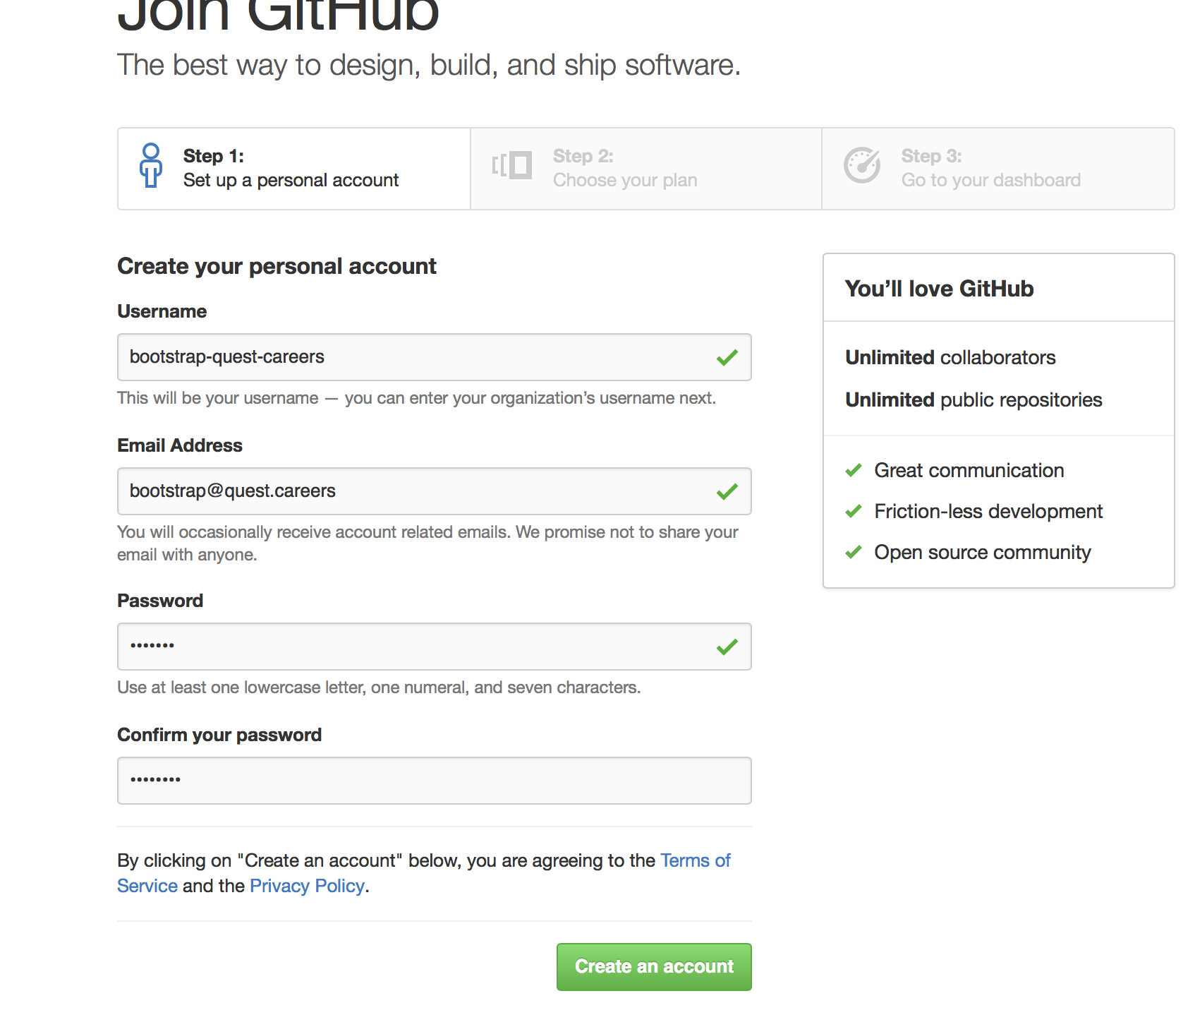

1. Setup Organisation:

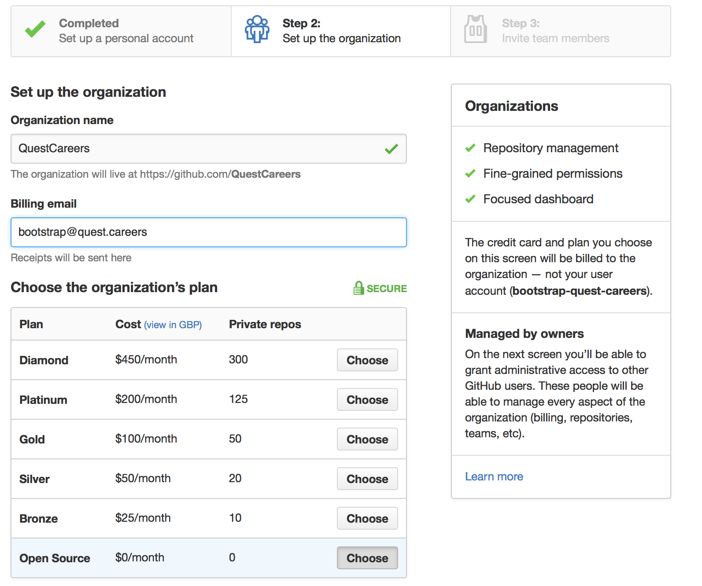

1. URL of the Organization is:
   1. [https://github.com/**QuestCareers**](https://github.com/QuestCareers)
2. Create a repository in github

- Created “**Quest-Documents**”

1. Create SSH Key for pushing code to git hub. This is needed a secure connection
2. The private key will be in PC and public key will be in github
   1. Create a folder Quest-Documents
   2. Go to terminal
   3. Back up the .ssh folder in profile/home directory
   4. Command :
      1. ssh-keygen –t rsa –C “[bootstrap@quest.careers](mailto:bootstrap@quest.careers)”
         1. –t gives the type of key
         2. –C is comment where we provide the email id

$ ssh-keygen -t rsa -C "bootstrap@quest.careers"

Generating public/private rsa key pair.

Enter file in which to save the key (/Users/bborah/.ssh/id_rsa): key-quest-careers-git

Enter passphrase (empty for no passphrase): <<Boot123>>

Enter same passphrase again:

Your identification has been saved in key-quest-careers-git.

Your public key has been saved in key-quest-careers-git.pub.

The key fingerprint is:

c0:1f:74:67:8b:f7:69:e0:99:ca:e2:f3:19:73:ce:7a bootstrap@quest.careers

The key's randomart image is:

+--[ RSA 2048]----+

| . . o |

| . . . + . |

| o . . + |

| o . o = . |

| S + + |

| . . . |

| . = . |

| ... BE |

| .o+oo |

+-----------------+

1. Open the RSA.pub and copy the key
2. Open gitub -> settings -> SSH key
3. Add the key

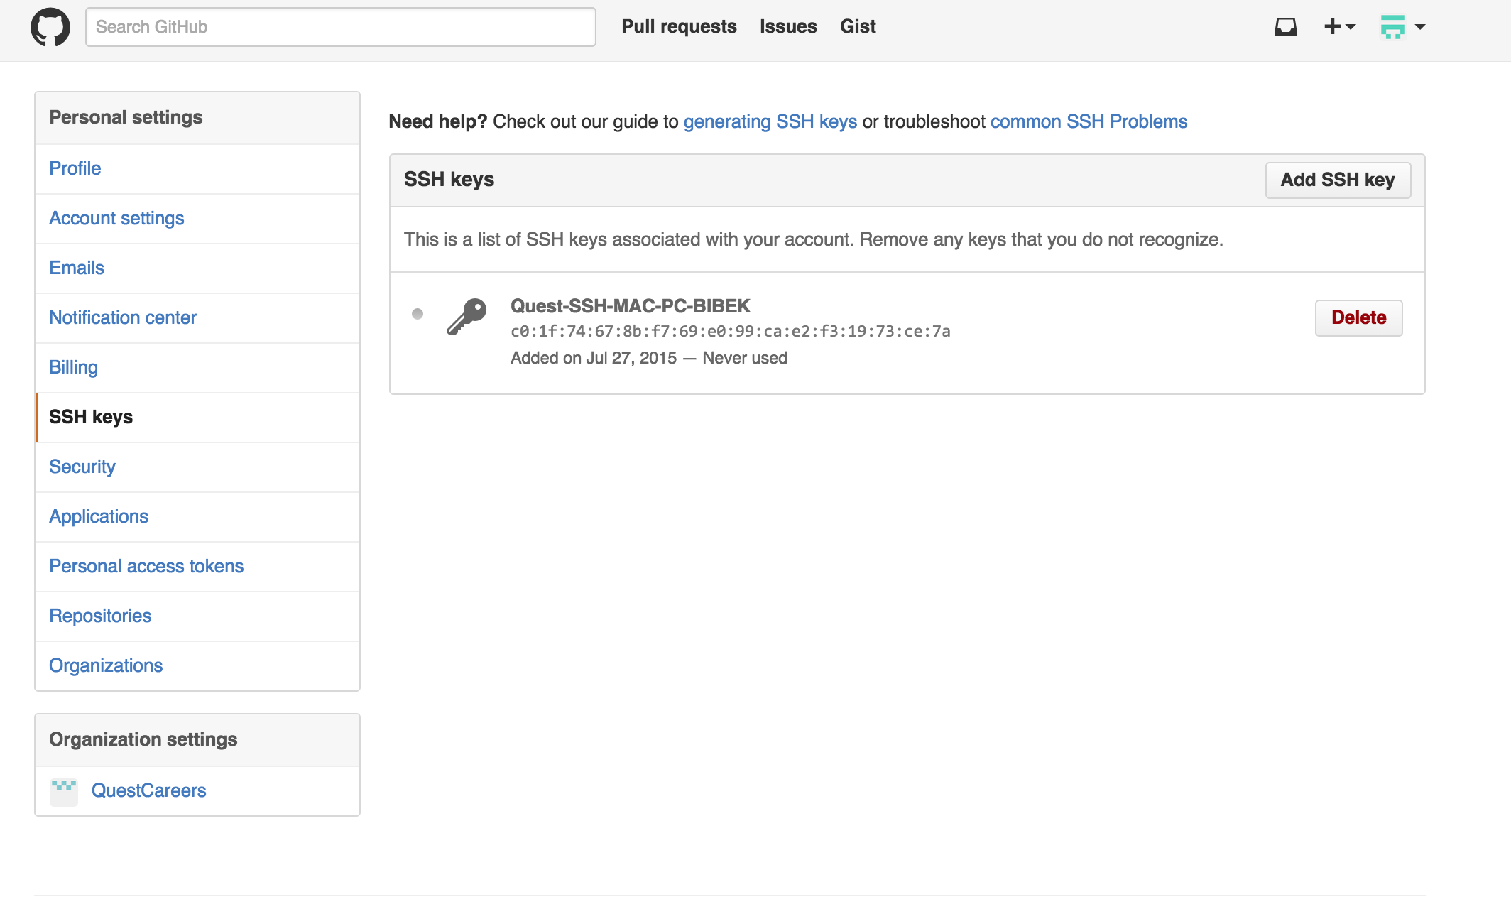

1. Test the connection
   1. ssh –T bootstrap@quest.careers
2. Test the connection:

$ ssh -vT git@github.com

OpenSSH_6.2p2, OSSLShim 0.9.8r 8 Dec 2011

debug1: Reading configuration data /etc/ssh_config

debug1: /etc/ssh_config line 20: Applying options for *

debug1: Connecting to github.com [192.30.252.131] port 22.

debug1: Connection established.

debug1: identity file /Users/bborah/.ssh/id_rsa type 1

debug1: identity file /Users/bborah/.ssh/id_rsa-cert type -1

debug1: identity file /Users/bborah/.ssh/id_dsa type -1

debug1: identity file /Users/bborah/.ssh/id_dsa-cert type -1

debug1: Enabling compatibility mode for protocol 2.0

debug1: Local version string SSH-2.0-OpenSSH_6.2

debug1: Remote protocol version 2.0, remote software version libssh-0.7.0

debug1: no match: libssh-0.7.0

debug1: SSH2_MSG_KEXINIT sent

debug1: SSH2_MSG_KEXINIT received

debug1: kex: server->client aes128-ctr hmac-sha1 none

debug1: kex: client->server aes128-ctr hmac-sha1 none

debug1: sending SSH2_MSG_KEXDH_INIT

debug1: expecting SSH2_MSG_KEXDH_REPLY

debug1: Server host key: RSA 16:27:ac:a5:76:28:2d:36:63:1b:56:4d:eb:df:a6:48

The authenticity of host 'github.com (192.30.252.131)' can't be established.

RSA key fingerprint is 16:27:ac:a5:76:28:2d:36:63:1b:56:4d:eb:df:a6:48.

Are you sure you want to continue connecting (yes/no)? yes

Warning: Permanently added 'github.com,192.30.252.131' (RSA) to the list of known hosts.

debug1: ssh_rsa_verify: signature correct

debug1: SSH2_MSG_NEWKEYS sent

debug1: expecting SSH2_MSG_NEWKEYS

debug1: SSH2_MSG_NEWKEYS received

debug1: Roaming not allowed by server

debug1: SSH2_MSG_SERVICE_REQUEST sent

debug1: SSH2_MSG_SERVICE_ACCEPT received

debug1: Authentications that can continue: publickey

debug1: Next authentication method: publickey

debug1: Offering RSA public key: /Users/bborah/.ssh/id_rsa

debug1: Server accepts key: pkalg ssh-rsa blen 535

debug1: key_parse_private_pem: PEM_read_PrivateKey failed

debug1: read PEM private key done: type <unknown>

Saving password to keychain failed

debug1: key_parse_private_pem: PEM_read_PrivateKey failed

debug1: read PEM private key done: type <unknown>

debug1: key_parse_private_pem: PEM_read_PrivateKey failed

debug1: read PEM private key done: type <unknown>

Saving password to keychain failed

debug1: read PEM private key done: type RSA

Identity added: /Users/bborah/.ssh/id_rsa (/Users/bborah/.ssh/id_rsa)

debug1: read PEM private key done: type RSA

debug1: Authentication succeeded (publickey).

Authenticated to github.com ([192.30.252.131]:22).

debug1: channel 0: new [client-session]

debug1: Entering interactive session.

debug1: Sending environment.

debug1: Sending env LANG = en_GB.UTF-8

debug1: client_input_channel_req: channel 0 rtype exit-status reply 0

Hi bootstrap-quest-careers! You've successfully authenticated, but GitHub does not provide shell access.

debug1: channel 0: free: client-session, nchannels 1

Transferred: sent 3896, received 2296 bytes, in 0.2 seconds

Bytes per second: sent 18253.7, received 10757.3

debug1: Exit status 1

1. Upload project to github:

$ pwd

/Users/bborah/Developer/Quest-Documents

$ git init

Initialized empty Git repository in /Users/bborah/Developer/Quest-Documents/.git/

$ git add .

$ git status

On branch master

Initial commit

Changes to be committed:

(use "git rm --cached <file>..." to unstage)

new file: Git Installation and configuration.docx

new file: MEANJS - Install for Quest Careers.docx

$ git commit -m "First commit for the documents"

[master (root-commit) 349ae1e] First commit for the documents

2 files changed, 0 insertions(+), 0 deletions(-)

create mode 100644 Git Installation and configuration.docx

create mode 100644 MEANJS - Install for Quest Careers.docx

$ git status

On branch master

nothing to commit, working directory clean

NOW ADD TO GITHUB

1. Adding remote repository. Goto github and to the repository. Goto SSH tab there and copy the link:

$ git remote add origin git@github.com:bootstrap-quest-careers/Quest-Documents.git

$ git push origin master

Warning: Permanently added the RSA host key for IP address '192.30.252.130' to the list of known hosts.

Counting objects: 4, done.

Delta compression using up to 8 threads.

Compressing objects: 100% (4/4), done.

Writing objects: 100% (4/4), 2.10 MiB | 733.00 KiB/s, done.

Total 4 (delta 0), reused 0 (delta 0)

To git@github.com:bootstrap-quest-careers/Quest-Documents.git

* [new branch] master -> master

1. See the repository

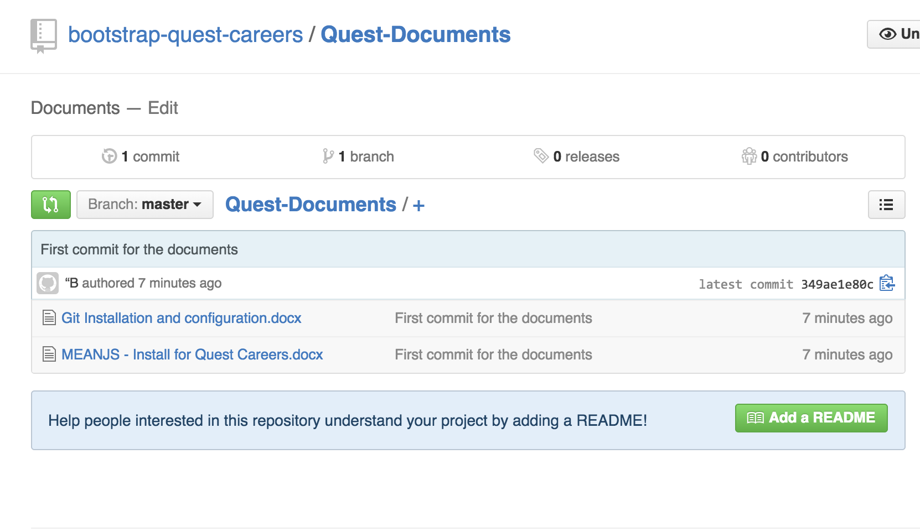

1. xx